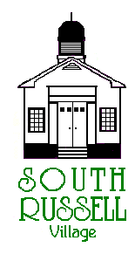 | Village of South Russell  5205 Chillicothe Road  South Russell, Ohio 44022  440-338-6700

ARCHITECTURAL REVIEW BOARD MEETING
AGENDA
March 16, 2021 – 5:30pm

____Gary Neola, Chairman ____Board Secretary Ruth Griswold
____Ryan Parsons ____Mayor Bill Koons
____Denis Marino

- Call to Order
- Roll Call
- Approval of Minutes from ARB Meeting held on March 2, 2021

Agenda Item 1:
Case # ARB 21-05(A)-5197 Chillicothe Road-Applicant and Owner’s Representative Marvin Miller of Hershberger Roofing & Siding-Installation of a standing seam metal roof on red barn. This applicant was tabled on March 2, 2021.

Old Business:

New Business:

ADJOURN

