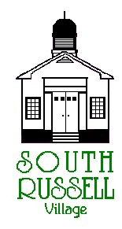
5205 Chillicothe Road
South Russell, Ohio 44022
440-338-6700

ARCHITECTURAL REVIEW BOARD MEETING
AGENDA
January 19, 2021 - 5:30 P.M.

Roll Call:
_____ Gary Neola, Chairman _____ Ruth Griswold, Board Secretary
_____ Ryan Parsons _____ Mayor Bill Koons
_____ Denis Marino

APPROVAL OF MINUTES FROM DECEMBER 15, 2020

CASE #ARB 21-01: 103 HAZELWOOD DRIVE– WILLIAM JOYCE OF JOYCE BUILDING COMPANY, OWNER AND APPLICANT–NEW RESIDENTIAL HOUSE
The applicant received variances from the BZA on 1-13-2021 for a 18 ¾” side yard setback on west side of house and 1’ side yard setback on the east side of the house.

CASE #ARB 21-02: 1281 BELL ROAD-WENDY REPCHICK, OWNER/APPLICANT AND MARTIN JOHANNESEN, ARCHITECT -NEW TWO CAR GARAGE ABD EXTERIOR RENOVATIONS OF EXISTING HOUSE

OLD BUSINESS:

NEW BUSINESS:

ADJOURN

