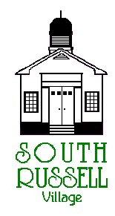
5205 Chillicothe Road
South Russell, Ohio 44022
440-338-6700

PLANNING COMMISSION MEETING
AGENDA
July 9, 2020 - 7:30 P.M.
**THIS MEETING WILL BE CONDUCTED VIA ZOOM**
Meeting number is 869 5469 3640
Password is 230365
1-929-205-6099 for phone
(If there are any issues logging in, please call Mayor Koons at (440) 227-1346)
Roll Call:
_____ Steve Latkovic, Chairman _____ Bridey Matheney, Solicitor
_____ James Flaiz _____ Nancy Grattino, Board Secretary
_____ Dennis Galicki _____ ____________________________
_____ William Koons, Mayor _____ ____________________________
_____ Elisa Budoff _____ ____________________________

CASE # 20-PC-02: 477 INDUSTRIAL PKWY, SUITE B – ALLEGRIA STUDIO – PETER CARY, APPLICANT/ PROP. OWNERS REP. – PROPOSED NEW TENANT
The applicant has a new tenant for a Cosmetic and Medical Tattoo Clinic business to occupy this space and is asking for approval. Zoning is met for this type of business at this location.

APPROVAL OF MINUTES:

OLD BUSINESS:

NEW BUSINESS:
ADJOURN

