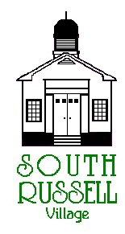
5205 Chillicothe Road
South Russell, Ohio 44022
440-338-6700

ARCHITECTURAL REVIEW BOARD MEETING
AGENDA
AUGUST 4, 2020 - 5:30 P.M.

Roll Call:
_____ Gary Neola, Chairman _____ Nancy Grattino, Board Secretary
_____ Ryan Parsons _____ Mayor Bill Koons
_____ Denis Marino _____ ____________________________

CASE # 20-ARB-24: 47 MAPLE HILL DRIVE– LAWRENCE & CONNIE HO – OWNERS / APPLICANTS- 2-CAR ATTACHED GARAGE & PATIO - CONTINUATION
The applicant is proposing a 2-car attached garage and patio – revised submittal.

APPROVAL OF MINUTES:

OLD BUSINESS:

NEW BUSINESS:

ADJOURN

