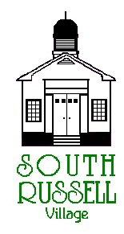

5205 Chillicothe Road

South Russell, Ohio 44022

440-338-6700

**ARCHITECTURAL REVIEW BOARD MEETING**

**AGENDA**

**JULY 7, 2020 - 5:30 P.M.**

**Roll Call:**

**_____ Gary Neola, Chairman _____ Nancy Grattino, Board Secretary**

**_____ Ryan Parsons _____ Mayor Bill Koons**

**_____ Denis Marino _____ ____________________________**

**CASE # 20-ARB-15: 7639 EAST WASHINGTON STREET – C.V. ROTARY – WILLIAM KOONS, APPLICANT – PROPOSED MONUMENT SIGN**

The applicant is proposing a 6’ monument sign. Approval has been given by the property owner for this sign.

**CASE #20-ARB-16: 5210 CHILLICOTHE ROAD – CIPRIANI CO. SHOPPING STRIP – BECKER SIGNS, APPLICANT – PROPOSED SIGN CRITERIA FOR SHOPPING STRIP**

The applicant is proposing a sign criteria for the shopping strip which is under a façade renovation. Once approved, they will come back with the individual unit signs for approval.

**APPROVAL OF MINUTES:**

**OLD BUSINESS:**

**NEW BUSINESS:**

**ADJOURN**