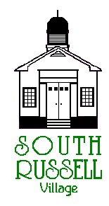
5205 Chillicothe Road
South Russell, Ohio 44022
440-338-6700

BOARD OF ZONING APPEALS
Agenda
JUNE 17, 2020
7:00 pm
**THIS MEETING WILL BE CONDUCTED VIA ZOOM**
Meeting number is 867 6577 1224
Password is 477743
(If there are any issues logging in, please call Mayor Koons at (440) 227-1346)

Roll Call:
_____ David Maistros, Chairman _____ Bridey Matheney, Solicitor
_____ Andy Hitchcock _____ Nancy Grattino, Board Secretary
_____ Laura LaChapelle _____ Dave Hocevar, CBO/Inspector
_____ Bill Stone _____ ____________________________
_____ Mike Mulloy _____ ____________________________

APPROVAL OF MINUTES: May 20, 2020

OLD BUSINESS

NEW BUSINESS

ADJOURN

