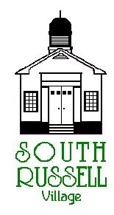
5205 Chillicothe Road
South Russell, Ohio 44022
440-338-6700

ARCHITECTURAL REVIEW BOARD MEETING
AGENDA
JUNE 16, 2020 - 5:30 P.M.

Roll Call:
_____ Gary Neola, Chairman _____ Nancy Grattino, Board Secretary
_____ Ryan Parsons _____ Mayor Bill Koons
_____ Denis Marino _____ ____________________________

CASE # 20-ARB-11: 494 LAURELBROOK DRIVE – ADAM & DANA GENT (OWNER’S) – CATHERINE MIDDLETON (ARCHITECT) – APPLICANT/ REP. – PROPOSED SCREENED PORCH - CONTINUATION
The applicant is proposing to replace his existing deck and add a screened porch.

CASE # 20-ARB-13: 36 FOREST DRIVE – RICHARD & JANET SMITH (OWNER’S) – PROPOSED SHED/CARPORT
The applicant is proposing to replace his existing shed with a new 499 S.F. shed/carport.

CASE # 20-ARB-14: 490 LAURELBROOK DRIVE – MARLO & CRAIG PECK (OWNER’S) – REBECCA PANTUSO (ARCHITECT) – APPLICANT/REP. – PROPOSED POOL HOUSE
The applicant is proposing a pool house.

APPROVAL OF MINUTES:

OLD BUSINESS:

NEW BUSINESS:

ADJOURN

