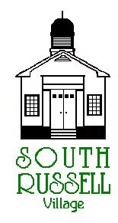
5205 Chillicothe Road
South Russell, Ohio 44022
440-338-6700

ARCHITECTURAL REVIEW BOARD MEETING
AGENDA
MARCH 17, 2020 - 5:30 P.M.

Roll Call:
_____ Gary Neola, Chairman _____ Nancy Grattino, Board Secretary
_____ Ryan Parsons _____ ____________________________
_____ Denis Marino _____ ____________________________

CASE # 20-ARB-05: 95 FOXHALL DRIVE – ROBERT & ROSEMARY PATNO – APPLICANT/OWNER – PROPOSED 3-SEASON ROOM (REPLACING EXISTING DECK)- CONTINUATION
The applicant is proposing to remove their existing deck and replace with a slightly larger 3-Season room.

CASE # 20-ARB-06: 84 PAW PAW LAKE DRIVE – BRITT SMITH – APPLICANT/OWNER – PROPOSED SHED REPLACEMENT
The applicant is proposing to remove the existing 10X18 shed and replacing it with a 16X24 shed and adding a 4X7 covered porch.

OLD BUSINESS:

NEW BUSINESS:

ADJOURN

