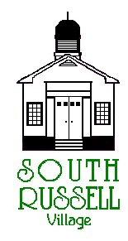
5205 Chillicothe Road
South Russell, Ohio 44022
440-338-6700

ARCHITECTURAL REVIEW BOARD MEETING
AGENDA
FEBRUARY 18, 2020 - 5:30 P.M.

Roll Call:
_____ Gary Neola, Chairman _____ Nancy Grattino, Board Secretary
_____ Ryan Parsons _____ ____________________________
_____ Denis Marino _____ ____________________________

CASE # 20-ARB-04: 5210 CHILLICOTHE ROAD – CIPRIANI COMPANIES- MIKE CIPRIANI, OWNER – FAÇADE RENOVATION
The applicant is proposing a façade renovation to the existing building with no change of building size.

APPROVAL OF MINUTES: February 4, 2020

OLD BUSINESS:

NEW BUSINESS:

ADJOURN

