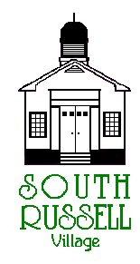
5205 Chillicothe Road
South Russell, Ohio 44022
440-338-6700

ARCHITECTURAL REVIEW BOARD MEETING
AGENDA
FEBRUARY 4, 2020 - 5:30 P.M.

Roll Call:
_____ Gary Neola, Chairman _____ Nancy Grattino, Board Secretary
_____ Ryan Parsons _____ ____________________________
_____ Denis Marino _____ ____________________________

APPROVAL OF MINUTES: November 5, 2019

OLD BUSINESS: BZA Case # 20-BZA-01- 48 Daisy Lane Appeal - forwarded back to ARB for clarification of what specifically was denied on November 5, 2019 by ABR for Exterior Modifications. (CONTINUATION)

NEW BUSINESS:

ADJOURN

