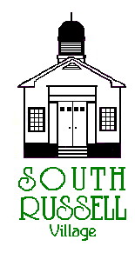 | Village of South Russell  5205 Chillicothe Road  South Russell, Ohio 44022  440-338-6700 Fax 440-338-8776

PLANNING COMMISSION
MEETING AND PUBLIC HEARING
AGENDA
November 14, 2019 - 7:30 P.M.

- Roll Call

- Guests

- Approval of Minutes: June 13, 2019

- Discussion:

1208 BELL ROAD – PPN: 29-029100 – MC STUDIO LLC – CARLENE HOLTZ (APPLICANT) – ART STUDIO/OFFICE
The applicant is proposing to expand her existing business to South Russell to include an art gallery, admin. Office, art classes and art activities.

- Old Business

- New Business

- Adjourn

