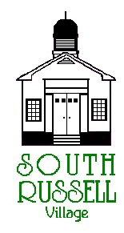
5205 Chillicothe Road
South Russell, Ohio 44022
440-338-6700

PLANNING COMMISSION
Meeting and Public Hearing
Agenda
February 7, 2019
7:30 pm

Roll Call

Approval of Minutes
Agenda:
- Continuation of the development review for a proposed kiosk addition at 1194 Bell Road, South Russell, OH for Citizens Bank.

Old Business
New Business
Adjourn

